Contents
1 Introduction 2
1.1 Definition 2
1.2 Attributes 2
1.3 History 4
2 Architecture 4
3 Cloud computing categories 6
4 Intergration 7
4.1 End to end design - definition 7
4.2 Examples 10
5 Pros and Cons 11
5.1 Pros 11
5.2 Cons 13
6 Operation 14
6.1 Service management 14
6.2 Administration 15
6.3 Monitoring 17
6.4 Support 18
6.5 Control 18
7 Conclusion 19

1 Introduction
This text provides you with a basic information about the Cloud Computing, a new and fastly growing term. It is structured to seven chapters for better orientation and easy understanding. The first chapter talks about the very basis such as definition, its attributes or history.

1.1 Definition
Cloud Computing is a buzzword of 2010 and many experts disagree on its exact definition. But the most used one and concurred one includes the notion of web‐based services which are available on demand from and optimized and highly scalable service provider. Since such a disagreement on the definition, one will be provided to better understand of the notion. The cloud is IT as a service, delivered by IT resources that are independent of location. It is a style of computing in which dynamically scalable and often virtualized resources are provided as a service over the Internet where end‐users have no knowledge of, expertise in, or control over the technology infrastructure (the cloud) that supports them. [1]

1.2 Attributes
Before some of the attributes will be defined, the term cloud should be explained. A cloud has been long used in IT, in network diagrams respectively, to represent a sort of black box where the interfaces are well known but the internal routing and processing is not visible to the network users. Key attributes in cloud computing:

- Service‐Based: Consumer concerns are abstracted from provider concerns through service interfaces that are well‐defined. The interfaces hide the implementation details and enable a completely automated response by the service provider. The service could be considered "ready to use" or "off the shelf" because it is designed to serve the specific needs of a set of consumers, and the technologies are tailored to that need rather than the service being tailored to how the technology works. The articulation of the service feature is based on service levels and IT outcomes such as availability, response time, performance versus price, and clear and predefined operational processes, rather than technology and its capabilities. In other words, what the service needs to do is more important than how the technologies are used to implement the solution.
- Scalable and Elastic: The service can scale capacity up or down as the consumer demands at the speed of full automation (from seconds for some services to hours for others). Elasticity is a trait of shared pools of resources. Scalability is a feature of the underlying infrastructure and software platforms. Elasticity is associated with not only scale but also an economic model that enables scaling in both directions in an automated fashion. This means that services scale on demand to add or remove resources as needed.
- Shared: Services share a pool of resources to build economies of scale and IT resources are used with maximum efficiency. The underlying infrastructure, software or platforms are shared among the consumers of the service (usually unknown to the consumers). This enables unused resources to serve multiple needs for multiple consumers, all working at the same time.
- Metered by Use: Services are tracked with usage metrics to enable multiple payment models. The service provider has a usage accounting model for measuring the use of the services, which could then be used to create different pricing plans and models. These may include pay‐as‐you go plans, subscriptions, fixed plans and even free plans. The implied payment plans will be based on usage, not on the cost of the equipment. These plans are based on the amount of the service used by the consumers, which may be in terms of hours, data transfers or other use‐based attributes delivered.
- Uses Internet Technologies: The service is delivered using Internet identifiers, formats and protocols, such as URLs, HTTP, IP and representational state transfer Web‐oriented architecture. Many examples of Web technology exist as the foundation for Internet‐based services. Google's Gmail, Amazon.com's book buying, eBay's auctions sharing all exhibit the use of Internet and Web technologies and protocols. More details about examples are in the chapter four – Intergration [2]

1.3 History
History of Cloud Computing surprisingly began almost 50 years ago. The father of this idea is considered to be John McCarthy, a professor at MIT University in US, who first in 1961 presented the idea of sharing the same computer technology as being the same as for example sharing electricity. Electrical power needs many households/firms that possess a variety of electrical appliances but do not possess power plant. One power plant serves many customers and using the electricity example, power plant=service provider, distribution network=internet and the households/firms=computers. [3]
Since that time, Cloud computing has evolved through a number of phases which include grid and utility computing, application service provision (ASP), and Software as a Service (SaaS). One of the first milestones was the arrival of Salesforce.com in 1999, which pioneered the concept of delivering enterprise applications via a simple website. The next development was Amazon Web Services in 2002, which provided a suite of cloud‐based services including storage, computation and even human intelligence. Another big milestone came in 2009 as Google and others started to offer browser‐based enterprise applications, though services such as Google Apps. [4]

2 Architecture
A basis infromation about the architecture is provided in this chapter, together with the explanations of relevant terms such as virtualization, Frond/Back end or Middleware.

- Virtualization is best described as essentially designating one computer to do the job of multiple computers by sharing the resources of that single computer across multiple environments. Virtual servers and virtual desktops allow you to host multiple operating systems and multiple applications locally and in remote locations, freeing your business from physical and geographical limitations. [5]

The Cloud Computing architecture can be divided into two sections, the front end and the back end, connected together through a network, usually Internet. The Front End includes the client's computer and the application required to access the cloud computing system. Not all cloud computing systems have the same user interface. Services like Web‐based e‐mail programs leverage existing Web browsers like Internet Explorer or Firefox. Other systems have unique applications that provide network access to clients.

The Back End of the system is represented by various computers, servers and data storage systems that create the "cloud" of computing services. Practically, Cloud Computing system could include any program, from data processing to video games and each application will have its own server.
A central server administers the system, monitoring traffic and client demands to ensure everything runs smoothly. It follows a set of rules called protocols and uses a special kind of software called Middleware. Middleware allows networked computers to communicate with each other. [6]
Public Cloud (external cloud) is a model where services are available from a provider over the Internet, such as applications and storage. There are free Public Cloud Services available, as well as pay‐per‐usage or other monetized models. Private Cloud (Internal Cloud/Corporate Cloud) is computing architecture providing hosted services to a limited number of people behind a company’s protective firewall and it sometimes attracts criticism as firms still have to buy, build, and manage some resources and thus do not benefit from lower up‐front capital costs and less hands‐on management, the core concept of Cloud Computing. [7]
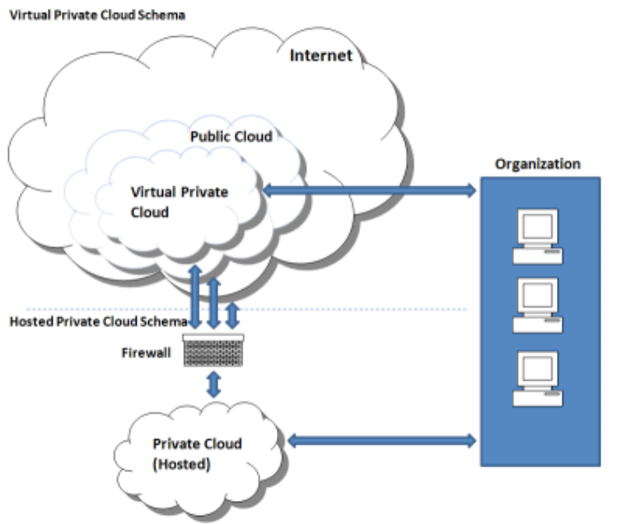
Private/Public cloud
Source: http://www.technologyevaluation.com/login.aspx?returnURL=http://www.technologyevaluation.com%2fresearch%2farticles%2fi-want-my-private-cloud-21964%2f

3 Cloud computing categories
There are three main categories in CC, Infrastructure as a Service (IaaS), Software as a Service (SaaS) and Platform as a Service (PaaS). All of them are described below in more details.

- Infrastructure as a Service is a provision model in which an organization outsources the equipment used to support operations, including storage, hardware, servers and networking components. The service provider owns the equipment and is responsible for housing, running and maintaining it. [8]
- Software as a Service is a software distribution model in which applications are hosted by a vendor or service provider and made available to customers over a network, typically the Internet. It is becoming an increasingly prevalent delivery model as underlying technologies that support Web services and service‐oriented architecture become increasingly available. [9]
- Platform as a Service is an outgrowth of Software as a Service (SaaS). It is a way to rent hardware, operating systems, storage and network capacity over the Internet. The service delivery model allows the customer to rent virtualized servers and associated services for running existing applications or developing and testing new ones. [10]

4 Intergration
Once the definition, categories and componencts needed for the user´s solution have been identified the next challenge is to determine how to put them all together. This chapter provides information about the Cloud Computing degisn and integrability as well as gives some examples.

4.1 End to end design - definition
It is a major feature of the Internet. The intelligence and functions in an Internet‐based application reside at both ends of the network (client side and server side), not within the Internet backbone. The Internet acts as a transport between these two.

- Technical design – in its simplest form, the end‐to‐end design will include the end‐user device, user connectivity, Internet, cloud connectivity, and the cloud itself.

At a minimum, most organizations will have users who connect to the cloud service remotely (from home or while travelling) and through the internal network. In addition to connectivity at the network level, the interfaces at the application layer need to be compatible and it will be necessary to ensure this connectivity is reliable and secure.

- Devices – cloud services should be device agnostic. They should work with traditional desktop, mobile devices and thin client. Unfortunately, this is much easier said than done. Regression testing on five or ten client platforms can be challenging. A good start is to bundle the sets of supported devices into separate services. With Microsoft Exchange 2007 you have the option of supporting Windows platforms through HTTP (Outlook web access) and using RPC over HTTP. You can also support Windows Mobile (as well as Symbian, iPhone and Blackberry devices using ActiveSync). The platform is just beginning. You would also want to take an inventory of existing systems to determine the actual operating platforms, which might range from Mac OS and Linux to Google Chrome, Android, Symbian, RIM Blackberry and iPhones.
- Connectivity – in order to assess the connectivity demands you need to identify all required connections. At high level the connections will include categories such as:
  - Enterprise to cloud
  - Remote to cloud
  - Remote to enterprise
  - Cloud to cloud
  - Cloud to enterprise

Once you put these together into a high level connectivity diagram you can then proceed to the next step of identifying and selecting connectivity options. Unless the systems are connected they cannot operate, at least for any extended periods of time. It the case of cloud computing, data and processing are both highly distributed making reliable, efficient and secure connectivity and are the most critical.

- Management – generally, for each component in the design we need to investigate how we will manage it. This includes all the end‐user devices, the connectivity, and legacy infrastructure and all the applications involved. The challenge of splitting management components will be that you may have policies that need to be kept synchronized. Imagine for example, that you have a minimum password length of 8 characters which is increased to 10. If you have only two management servers and this is not a frequent type of occurrence then you can easily apply challenge manually. However, if you are dealing with hundreds of management servers and you receive minor policy changes on a weekly basis you can imagine how cumbersome and error‐prone the task will become.
- Security – the impact of Cloud Computing on security is profound. There are some benefits and unfortunately some hurdles to overcome. One challenge in trying to evaluate security is that it tends to relate to all aspects of IT and, since Cloud Computing`s impact is similarly pervasive. Security domains:
- Access control – provides mechanism to protect critical resources from unauthorized access and modification while facilitating access to authorized users
- Cryptography ‐ presents various methods for taking legible, readable data, and transforming it into unreadable data for the purpose of secure transmission, and then using a key to transform it back into readable data when it reaches its destination. [11]
- Operations security – includes procedures for back‐ups and change control management.

The Cloud Computing Manifesto is a manifesto containing a "public declaration of principles and intentions" for cloud computing providers and vendors, annotated as "a call to action for the worldwide cloud community" and "dedicated belief that the cloud should be open". It follows the earlier development of the Cloud Computing Bill of Rights, which addresses similar issues from the users' point of view. [12]

4.2 Examples
Most common public known examples of a Cloud are Google Apps. This service provide number of on‐line applications like Word‐processor, Application for creating and editing presentations, documents storage and sharing, email functions with connection on MS Outlook or MS exchange services, account and contacts sharing, Instant Messenger functions, etc., all provided by Google. Other Clouds examples include CloudX Technology Group, Yahoo, E‐bay, Facebook, Citric XennApp, AJAX, etc.

Device using CC
- Chromebook ‐ is a mobile device running Google Chrome OS. The two first devices for sale are by Samsung and Acer Inc. and are slated for release on June 15, 2011 [14] Chromebook (CR‐48) is Google prototype model. These machines boot‐up very quickly and offer basic tools for internet communication. Such as 3G/4G and Wifi connectivity, Web cam and microphone, mobile processor and enought RAM for webbrowsing and works on‐line only. Basic Hardrive is optional.
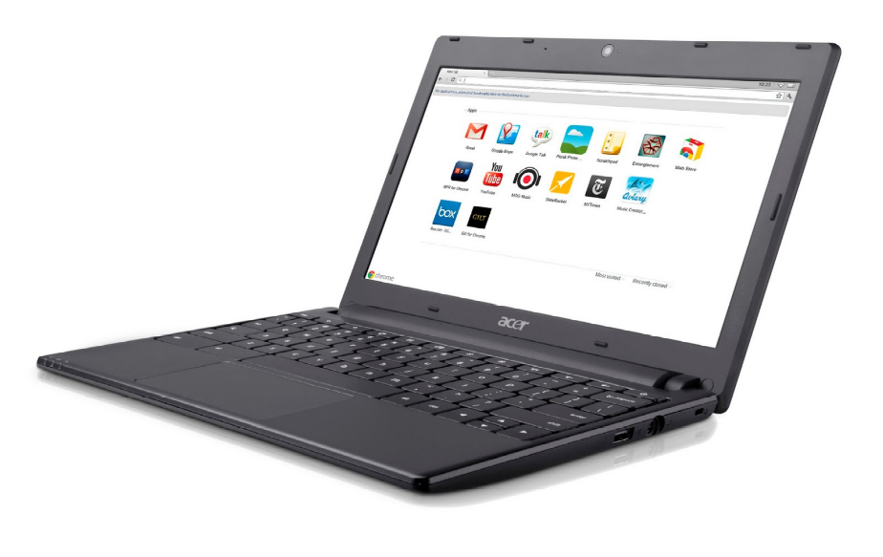
Chromebook by Acer
Source: http://gearburn.com/2011/05/chromebook-awesome-if-it-wasn%E2%80%99t-from-google/

5 Pros and Cons
Neither Cloud Computing is an exception and experience both prons and cons. Some of them are stated and described in more details in this chapter.

5.1 Pros
- Lower costs ‐ the principle of sharing resources (HW, SW, infrastructure...) gives to customer also the benefit of sharing its costs. Customer do not has to buy expensive hardware, such as powerful workstations, large server solution and software applications. Customer needs only internet connection and basic PC with not high requirements. Simple laptop, netbook or mobile phone is enought. Customer also pays only for what the real usege. These could be services, hardware resources or infrastructure or its combination.
- Less IT employees - there is also no neccesary by customer to employ IT department in such wide range. There is only need to provide secure connection and PC with webrowser. For all other, the technical support such as back-ups, recovery, virus protection, updates, software and hardware stability and functionality, helpdesk and support is maintained by the provider of a service.
- No special knowledge - client (customer) also does not need to have a high knowledge about hardware and complex software applications at all. Client just uses a service throught webrowser. Harware resources can be shared between all clients and managed by usage or their requirements.
- Easy to upgrade - massive increase of performance (such as speed or storage size) is provided immidiately after simple order and applied by “a few clicks”. Data centre can provide higher performance than common desktop PC or, on the other hand, can be very efficient and deliver just what customer needs at the moment (low performance) and thus again it saves resources and money. This approach saves also time, costs for new hardware, transport, is power (energy) efficient and as a result saves the environment, which is very discussed issue these days.
- Instant access anywhere - one of the most important benefit is availability of a service anywhere. What is needed for accessing the service is computer connected to the internet. There is no dependence on platform (PC, MAC, mobile phone, car etc.).
- Security - is a very discussed issue in the Cloud Computing service providing and could be put in both pros and cons as you see in a while. Service is protected by usage an authorization. Users identify themselves by using an ID (Username) and Password (or also more sophisticated method such as chip, fingerprint, face detection etc. can be used). Communication between client and provider servers is secured. Data centre is protected by firewalls and kept in secured buildings. There generally there is a very low risk of danger caused by attack of third parties. BUT on the other hand, a problem could be that client (customer) keeps all the data out of his computer – just at the providers´ servers. It means the client entrusts the data to the provider (provider company) and has in fact no physical control over them.
- Requirements - technology, which customer needs are very simple. Importatnt is only terminal as a laptop, desktop, mobile phone, netbook etc. with web‐browser, internet connection and usually also created account on a service at providers place.

5.2 Cons
- Legal differences – as already aforementioned, we can describe one particular example. US companies are obliged to follow the PATRIOT Act (2001) which states that companies can be watched and have to provide information and data about clients, if they are asked for in the correspondence of anti‐terrorist policy.
- Dependence on provider – if company starts using the Cloud Computing service and replaces its previous information system or changes IT structure, it becomes dependant on its service provider. Risks connected with such a dependency may include sudden change of prices or conditions of a contract. Provider could be hit by bankruptcy and end its business activities. Functions and applications might be changed without will of a customer and if a provider suffers from technical problems, all the customers are out of service which means without their data.
- Reputation – Cloud Computing is very new type of service. Not many companies has an experience with such a kind of services and application outsourcing. Many users are still worried about data security tranmitted over the internet.
- Migration costs – in some cases there can be higher start‐up costs. Company may have to invest into users training, any amendments which allows the communication of service provider and current company software and in some cases, switching to Cloud Computing could lead to a change of business processes.
- Less functions – solutions, which are targeted to the wide range of companies that can’t provide specific functions and therefore are not flexible.
- Dependence on internet connection ‐ all the Cloud Computing applications can be used on‐line only thus any connection failure could be fatal.

6 Operation
After reading through this chapter you will understand the terms such as administration, support or monitoring.

6.1 Service management
- Service strategy relates very closely to the Strategic Impact. Service providers only have limited resources and usually have more requests for services and functionality than can provide within their budget. In order to maximize their impact they must therefore prioritize these services. So IT organization must determine the value of potential internal and external services.
- Service design covers all elements relevant to the service delivery including service catalogue management, service level management, capacity management, availability management, IT service continuity management, information security management and supplier management. A key aspect of this design is the definition of service levels in terms of key performance indicators (KPIs). The key challenge is not to derive a number of KPIs, but to select a few that are critical to the overall strategy.
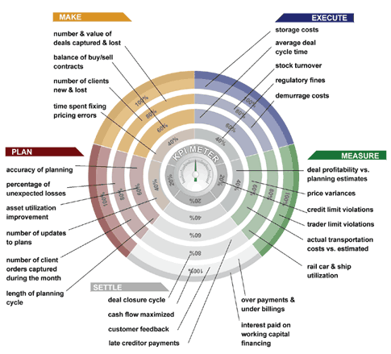
Example of KPIs
Source: http://mkhairul.sembangprogramming.com/2008/04/24/key-performance-indicators-kpi-for-software-development/

- Service transition represents the intersection between project and service management. In a cloud-based solution this is not only covers the initial implementation of cloud services but also any updates to them, launches of new services or retirement and migration of existing services.
- Service operation is the core of the ITIL model. Its focus is on the day-to-day operations that are required in order to deliver service to its users at the agreed levels of availability, reliability and performance. It includes concepts such as event management, incident management, problem management, access management, request fulfillment and service desk.

6.2 Administration
Since Cloud Computing is primarily web-based, the logical interface for administering is a portal. It can offer facilities such as billing, analytic, account management, service management, package install, configuration, instance flexing and tracing problems and incidents.
The area between service request and more extensive change management is not always obvious and depends to a large extent on the organization involved. However, in all companies there are likely to be services that are too critical for automated change requests.
One major recurring change is the need to perform upgrades to increase functionality, solve problems and sometimes improve performance. New version can disrupt services because they may drop functions, implement them differently or contain undiscovered bugs. It is therefore important to understand whether they will have any impact on business processes before rolling them out live. One approach is to stage all services locally and test them with on-premise equipment before overwriting the production services.
Long-term capacity management is less critical for on-demand services. Elasticity of resources means that enterprises can scale up and down as demand dictates without need for extensive planning. It´s also a good idea to verify that your services provider will actually be in a position to deliver all the resource requirements that you anticipate. Several aspects of capacity planning have to be evaluated in parallel.
Managing identities and access control for enterprise applications remains one of the greatest challenges facing IT today. While an enterprise may be able to leverage several Cloud Computing services without a good identity and access management strategy, in the long run extending an organization’s identity services into the cloud is a necessary precursor towards strategic use of on-demand computing services. Supporting today’s aggressive adoption of an admittedly immature cloud ecosystem requires an honest assessment of an organization’s readiness to conduct cloud-based Identity and Access Management (IAM), as well as understanding the capabilities of that organization’s Cloud Computing providers.

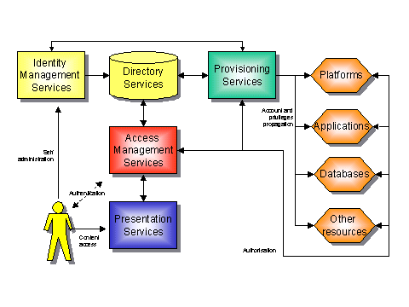
Identity and Access Management Model
Source: http://radio-weblogs.com/0100367/stories/2002/05/11/enterpriseIdentityAndAccessManagement.html

We will discuss the following major IAM functions that are essential for successful and effective management of identities in the cloud:
- Identity provisioning/deprovisioning
- Authentication
- Federation
- Authorization & user profile management [15]

6.3 Monitoring
Part of the incentive of moving to a public cloud is to reduce the amount of internal operational activity. Much of the internal infrastructure is local such as the printers, scanners and local equipment. End user desktops and mobile device s are also closer to on-site operations personnel. One area that is of particular concern to business continuity is backup. Backups are required for a variety of reasons including:
- End user access to data that has been removed
- End user access to historical data
- Audits, troubleshooting, IP retention
- Legal requirements for eDiscovery

Problem management refers to tracking and resolving unknown causes of incidents. It is closely related to Incident management but focuses on solving root causes for a set of incidents rather than applying what may be a temporary fix to an incident.

6.4 Support
There is some diversity in the user roles that may require assistance in a cloud solution. There are two types: end user and IT support. End-user support should progress in tiers that successively address more difficult and less common problems. It begins with simple documentation and on-line help to orient the user and clarify any obvious points of confusion. A self-service portal can then help to trigger automatic process to fulfill common requests.
In addition to end users there is also a requirement for IT and business users to receive assistance from the service providers. There must be mechanism in place for obtaining and sharing documentation and training on all cloud services and technologies. Vendor architecture diagrams and specifications for all technical interfaces can help IT staff.

6.5 Control
Most of the legal provisions that relate to cloud computing fall into one of three categories:
- Data privacy
- Electronic discovery
- Notification
There are also threats connected such as data leakage, data loss, non-compliance, loss of service and impairment of service

7 Conclusion
From the text and infromation aforementioned, you should have a basis information about what is Cloud Computing and its history, features or architecture. To summarize it, Cloud Computing is very new and modern technology based on sharing resources (especially software, hardware and infrastructure). It helps companies but also individuals in saving costs for IT resources. All data are stored out‐of‐company at a providers place which brings both advantages and disadbvnatges especially problematic issue about security and data privacy. Most common Cloud service you as a user may come across with are Google Apps.

Sources
[1] RHOTON, J, Cloud Computing Explained. 2.edition, Kent: Recursive Limited, 2011. 508 p. ISBN
9780956355607
[2] GARTNER NEWSROOM. Gartner Highlights Five Attributes of Cloud Computing. [online]. 2009. [cit.
2011‐05‐08]. Accessible at: <http://www.gartner.com/it/page.jsp?id=1035013>
[3] BUSINESSVIZE. Co je to Cloud computing a proč se o něm mluví . [online]. 2010. [cit. 2011‐05‐09].
Accessible at: <http://www.businessvize.cz/software/co‐je‐to‐cloud‐computing‐a‐proc‐se‐o‐nemmluvi>
[4] COMPUTERWEEKLY.COM. A history of cloud computing. [online]. 2009. [cit. 2011‐05‐08].
Accessible at: http://www.computerweekly.com/Articles/2009/06/10/235429/A‐history‐of‐cloudcomputing.
htm>
[5] MODCOMP. Virtualization & Cloud Computing. [online]. 2011. [cit. 2011‐05‐09]. Accessible at:
<http://www.modcomp.com/it‐solutions‐virtualization‐cloud‐computing>
[6]HOW STUFF WORKS. How Cloud Computing Works. [online]. 2011. [cit. 2011‐05‐10]. Accessible at:
<http://computer.howstuffworks.com/cloud‐computing1.htm>
[7] SLIDE SHARE. Cloud computing. [online]. 2011. [cit. 2011‐05‐09]. Accessible at:
<http://en.wikipedia.org/wiki/Cloud_computing#cite_note‐54>
[8] SEARCH CLOUD COMPUTING.COM. Infrastructure as a Service (IaaS). [online]. 2009. [cit. 2011‐05‐
10]. Accessible at: <http://searchcloudcomputing.techtarget.com/definition/Infrastructure‐as‐a‐
Service‐IaaS>
[9] SEARCH CLOUD COMPUTING.COM. Software as a Service (SaaS). [online]. 2006. [cit. 2011‐05‐10].
Accessible at: <http://searchcloudcomputing.techtarget.com/definition/Software‐as‐a‐Service>
[10] SEARCH CLOUD COMPUTING.COM. Platform as a Service (PaaS). [online]. 2008. [cit. 2011‐05‐
10]. Accessible at: <http://searchcloudcomputing.techtarget.com/definition/Platform‐as‐a‐Service‐
PaaS>
[11] WISEGEEK. What is Cryptography. [online]. 2011. [cit. 2011‐05‐08]. Accessible at:
<http://www.wisegeek.com/what‐is‐cryptography.htm>
[12] WIKIPEDIA. Cloud Computing Manifesto. [online]. 2010. [cit. 2011‐05‐09]. Accesiible at:
<http://en.wikipedia.org/wikiCloud_Computing_Manifesto>
[13] WIKIPEDIA. Cloud Computing. [online]. 2010. [cit. 2011‐05‐09]. Accesiible at:
<http://en.wikipedia.org/wiki/Cloud_computing>
[14] WIKIPEDIA. Chromebook. [online]. 2010. [cit. 2011‐05‐09].

